Practical 4
Determining linear transformation by knowing its action on basis vectors.

# Action of T on basis vectors
Te1 = [2, 1] # T(1, 0)
Te2 = [1, 3] # T(0, 1)

# Define linear transformation using basis action
def T(v):
x, y = v
return [
x * Te1[0] + y * Te2[0],
x * Te1[1] + y * Te2[1]
]

# Vector to transform
v = [3, 2]

# Result
print("Vector v =", v)
print("T(v) =", T(v))

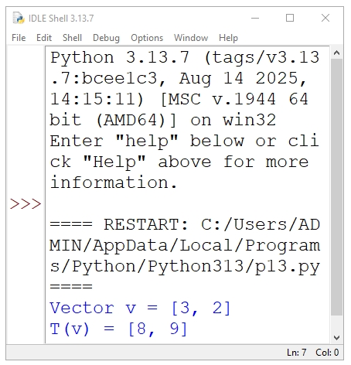

Practical 5
python program for Null space and image space of linear transformation.

import numpy as np

# Define transformation matrix A
A = np.array([[1, 2],
[2, 4]])

print("Matrix A:\n", A)

# ---- Image Space (Column Space) ----
# Columns of A span the image space
image_space = A[:, 0] # first column (others are dependent)

print("\nImage space is spanned by:")
print(image_space)

# ---- Null Space ----
# Solve A x = 0 using SVD
u, s, vh = np.linalg.svd(A)
tolerance = 1e-10
null_space = vh[s <= tolerance]

print("\nNull space vectors:")
print(null_space.T)

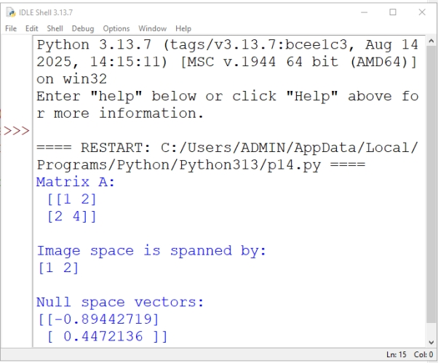

Practical 6
Python program for Computing matrix associated with a linear transformation.

import numpy as np

# Define the linear transformation
def T(v):
x, y = v
return np.array([2*x + y, x - y])

# Standard basis vectors in R^2
e1 = np.array([1, 0])
e2 = np.array([0, 1])

# Apply T to basis vectors
T_e1 = T(e1)
T_e2 = T(e2)

# Form the transformation matrix
A = np.column_stack((T_e1, T_e2))

print("Matrix associated with the linear transformation:")
print(A)

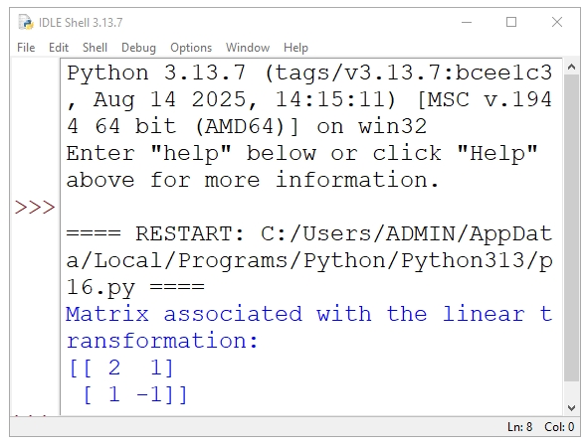

Practical 7
python program for Matrix associated with a composite of two linear transformations.

import numpy as np

# Matrix of T1: R^2 -> R^2
A = np.array([[1, 2],
[3, 4]])

# Matrix of T2: R^2 -> R^2
B = np.array([[2, 0],
[1, 5]])

# Matrix of composite transformation T = T2 ∘ T1
C = B @ A # Matrix multiplication

print("Matrix of T1:")
print(A)

print("\nMatrix of T2:")
print(B)

print("\nMatrix of composite transformation (T2 ∘ T1):")
print(C)

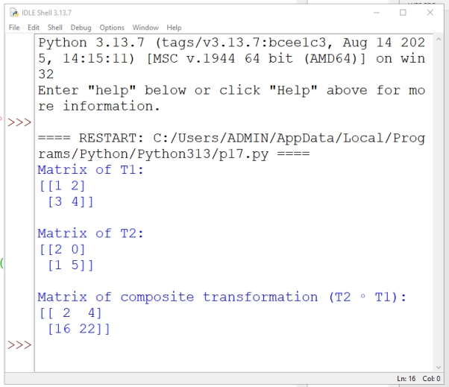

Practical 8

python program for Effect on change of basis on linear transformation.

import numpy as np

# Matrix of linear transformation in old basis
A = np.array([[2, 1],
[1, 3]])

# Change-of-basis matrix (new basis vectors as columns)
P = np.array([[1, 1],
[1, -1]])

# Compute inverse of P
P_inv = np.linalg.inv(P)

# Matrix in new basis
A_new = P_inv @ A @ P

print("Matrix in old basis (A):")
print(A)

print("\nChange-of-basis matrix (P):")
print(P)

print("\nMatrix in new basis:")
print(A_new)
